Project Milestone 1: Proposal & Literature Review
Heuristic Optimization for Multi-Agent Path Finding (MAPF) in Automated Warehouse Environments
Course: CS 57200: Heuristic Problem Solving
Student: Dishank Hanwate
Track: Track A (Algorithmic / Search)
1. Problem Definition
The transition from manual warehouses to automated, robotics-driven logistics relies heavily on intelligent routing. While finding the optimal path for a single robot is a trivial search problem, coordinating hundreds of robots simultaneously in a shared physical space is computationally intractable.
This project tackles the Multi-Agent Path Finding (MAPF) problem within an automated warehouse grid. The goal is to route k robots from their starting locations to designated pallet locations, and subsequently to loading docks, without any collisions or deadlocks.
Formal State-Space Specification
- State Representation (S): The environment is an N x N grid. A single state is a comprehensive snapshot of all agents and targets: S = ((r_1, s_1), (r_2, s_2), … , (r_k, s_k), p_1, p_2, ... , p_m).
  - r_i = (x, y) represents the grid coordinates of robot i.
  - s_i in {True, False} represents whether robot i is holding a pallet.
  - p_j = (x, y) represents the location of pallet j.
- Initial State (S_0): All k robots are at their respective charging station coordinates. All m pallets are at assigned shelf coordinates. Status s_i is False for all robots.
- Actions (A): At each discrete time step, every robot i can independently execute one action: A_i in {North, South, East, West, Wait, Lift, Drop}. A joint action is the vector of all individual actions: A_joint = <a_1, a_2, ..., a_k>.
- Transition Model & Constraints: A joint action is legal if and only if it results in no collisions. Collisions occur as either Vertex Conflicts (two robots moving to the same cell at the same time) or Edge Conflicts (two robots swapping adjacent cells).
- Goal Test: All pallets p_1 ... p_m are located at designated loading dock coordinates, and all robots have returned to a charging station with status False.
- Path Cost: The objective function is to minimize the Sum of Costs (SOC), calculated as the total number of actions (including Wait) taken by all agents to reach their goals.
- Estimated Complexity: For a grid of size N x N and k robots, the branching factor for a joint action is O(5^k), assuming 5 basic movement actions. The state space size grows exponentially as O((N^2)^k). This demonstrates graduate-level computational complexity, necessitating advanced heuristics over standard search algorithms.

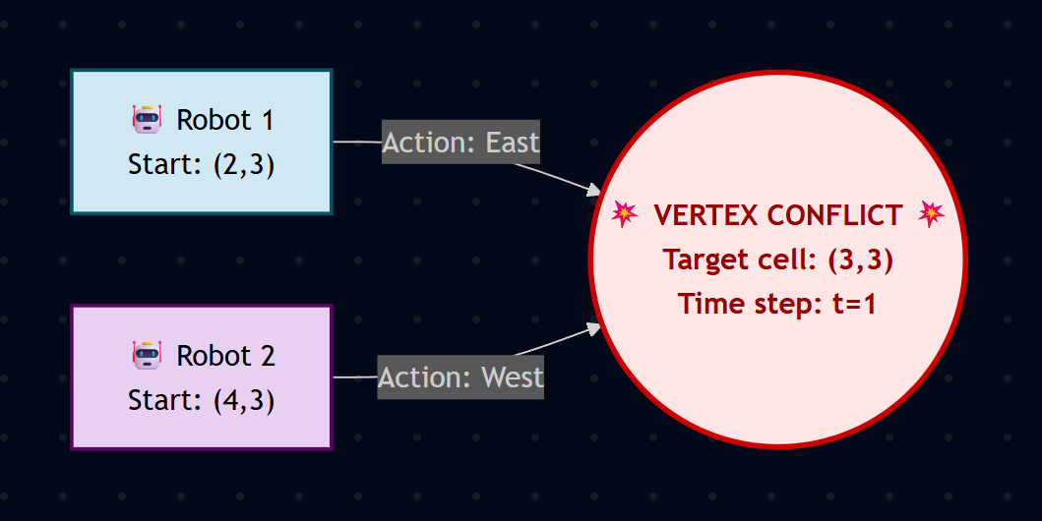
Figure 1: Illustration of a Vertex Conflict where two agents attempt to occupy the same grid coordinate at the same time step.

2. Literature Review
The Multi-Agent Path Finding (MAPF) domain has evolved significantly over the last two decades, driven largely by commercial logistics systems such as Amazon Robotics. Foundational search literature defines the baseline for pathfinding algorithms, where standard algorithms like A* are optimal for single agents but fail exponentially as the state space expands with multiple agents [1]. Early industrial adaptations in warehouse coordination heavily relied on strict traffic rules and localized zones to prevent collisions, which significantly limited throughput [2]. As defined by Stern et al. [6], modern MAPF removes these manual constraints, treating the grid as an open, shared resource that requires dynamic algorithmic coordination.
To bypass the intractable joint state space of O(5^k), early MAPF literature explored decoupled approaches. Silver introduced Cooperative A* (Space-Time A*), where agents plan paths individually in a prioritized order, treating higher-priority agents as moving obstacles in a space-time reservation table [3]. While highly efficient and memory-light, Standley formally proved that such decoupled algorithms are inherently suboptimal and often fail to find solutions in dense environments due to cascading deadlocks [4].
The current state-of-the-art approach shifts away from state-space search toward conflict resolution. Sharon et al. introduced Conflict-Based Search (CBS), a two-level algorithm that guarantees optimal SOC [5]. At the low level, CBS uses rapid A* to find single-agent paths while ignoring other robots. At the high level, it builds a constraint tree to resolve detected collisions. While CBS drastically reduces the branching factor compared to joint A*, its high-level tree still expands exponentially in highly congested bottleneck scenarios [5].
Recent research has focused on applying heuristics to the CBS framework to mitigate this bottleneck limitation. Felner et al. demonstrated that integrating standard heuristics, such as the Cardinal Conflict Count, into the high-level CBS tree can prune the search space significantly. This transforms CBS from a blind constraint search into an informed, heuristic-driven search [8]. Furthermore, Ma et al. extended these principles to "Lifelong MAPF," adapting the algorithms to continuous, online pickup and delivery tasks rather than one-off scenarios [7].
Synthesis and Project Gap: Existing literature highlights a strict trade-off. Decoupled algorithms (Space-Time A*) are fast but incomplete and suboptimal, while coupled algorithms (CBS) are optimal but struggle with scalability in dense warehouses. This project will bridge this gap by implementing and directly comparing both approaches, culminating in the development of a heuristically optimized CBS (h-CBS) agent. By designing a custom high-level evaluation function, the project will demonstrate how heuristic problem solving can force CBS to bypass deadlocks faster than the standard implementation.

3. Proposed Methodology
This project will follow an iterative development arc, beginning with a baseline implementation and advancing to state-of-the-art heuristic optimizations.
- Baseline Algorithm (Decoupled Space-Time A):* The starting point will be a prioritized reservation system. Robots will plan sequentially using A* over a 3D grid (X, Y, Time). Once a robot claims a space-time node, subsequent robots treat it as an obstacle.
- First Enhancement (Conflict-Based Search): To address the suboptimality and deadlocks of the baseline, the standard CBS algorithm will be implemented. This requires writing a low-level individual A* planner and a high-level Conflict Tree manager that issues spatial and temporal constraints (e.g., "Robot 1 cannot be at grid location 2,3 at time 5").
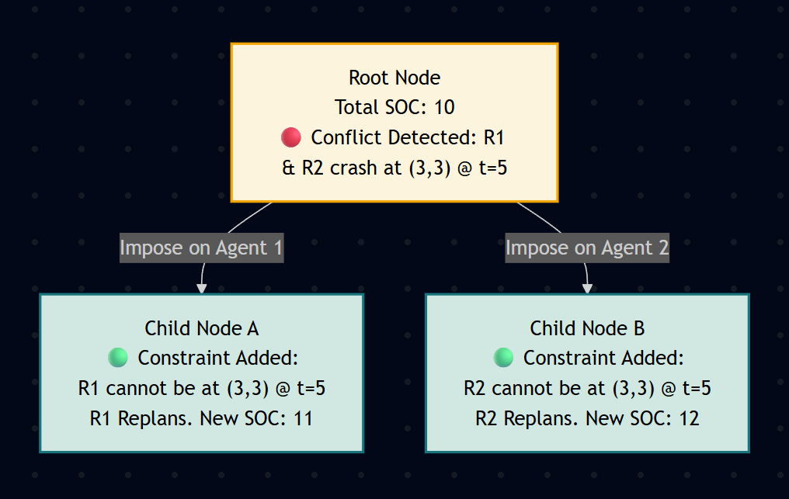
Figure 2: The high-level constraint tree of the CBS algorithm, branching to resolve a collision at node (3,3).
- Second Enhancement (Heuristic CBS): The core heuristic innovation will be applied to the high-level CBS tree. Standard CBS explores constraints using Breadth-First Search. I will implement a custom heuristic evaluation function, h(n), that estimates the minimum number of unresolved conflicts remaining in a constraint node, transforming the high-level search into an A* process.
- Planned Experiments:
  - Density vs. Planning Time: Compare the execution time of Baseline A* vs. CBS as the ratio of static obstacles (shelves) increases on a 20 x 20 grid.
  - Scalability and Success Rate: Test the algorithms with an increasing number of agents (k = 5, 10, 20, 50). Record the percentage of instances where the Baseline fails to find a solution (due to deadlocks) compared to CBS.
  - Heuristic Pruning Efficiency: Measure the total number of high-level tree nodes expanded by standard CBS versus the heuristically enhanced CBS (h-CBS) to prove the value of the designed evaluation function.
- Anticipated Challenges and Mitigations: The primary challenge is the exponential memory overhead required to store the CBS constraint tree. To mitigate this, state hashing will be utilized. If memory limits are reached, the algorithm will be bounded by a maximum time cutoff, defaulting to the best-found decoupled solution.

4. Project Timeline
The project will follow a strict, milestone-driven schedule to ensure completion and allow adequate time for data collection.
Week | Milestone | Deliverable / Goal
7 | M1 Submission | This Proposal & Literature Review.
8 | Environment Setup | Develop the Python grid simulation, state representation, and action validation logic.
9 | (Spring Break) | —
10 | Baseline Implemented | First runnable Space-Time A* agent. Verify basic collision avoidance.
11 | First Enhancement | Standard Conflict-Based Search (CBS) implemented.
12 | Second Enhancement | Design and integration of the high-level heuristic function (h-CBS).
13 | Full Implementation | All algorithms integrated. Debugging edge cases and corner collisions.
14 | M2 Submission | Preliminary results and code checkpoint.
15 | Experiments & Refinement | Execute planned experiments. Collect data on scalability and node expansions.
16 | Final Submission | Final Written Report and Project Presentation.

5. References
[1] S. Russell and P. Norvig, Artificial Intelligence: A Modern Approach, 4th ed. Pearson, 2020.
[2] P. R. Wurman, R. D'Andrea, and M. Mountz, "Coordinating Hundreds of Cooperative, Autonomous Vehicles in Warehouses," AI Magazine, vol. 29, no. 1, pp. 9-20, 2008.
[3] D. Silver, "Cooperative Pathfinding," in Proceedings of Artificial Intelligence and Interactive Digital Entertainment (AIIDE), 2005, pp. 117-122.
[4] T. Standley, "Finding Optimal Solutions to Cooperative Pathfinding Problems," in Proceedings of the AAAI Conference on Artificial Intelligence, 2010, pp. 173-178.
[5] G. Sharon, R. Stern, A. Felner, and N. R. Sturtevant, "Conflict-based search for optimal multi-agent pathfinding," Artificial Intelligence, vol. 219, pp. 40-66, 2015.
[6] R. Stern et al., "Multi-Agent Pathfinding: Definitions, Variants, and Benchmarks," in Symposium on Combinatorial Search (SoCS), 2019.
[7] H. Ma, J. Li, T. K. Satish Kumar, and S. Koenig, "Lifelong Multi-Agent Path Finding for Online Pickup and Delivery Tasks," in Proceedings of AAMAS, 2017.
[8] A. Felner et al., "Adding Heuristics to Conflict-Based Search for Multi-Agent Path Finding," in International Conference on Automated Planning and Scheduling (ICAPS), 2018.

